**The Login Controls**:-  
There are following Login controls developed by the Microsoft which are used in ASP.NET Website as given below:-

1. Login
2. LoginView
3. LoginStatus
4. Loginname
5. PasswordRecovery
6. ChangePassword
7. CreateUserWizard
8. **The Login Control**:-  
   The Login control provides a user interface which contains username and password, that authenticate the username and password and grant the access to the desired  services on the basis of the credentials.  
   There are used some methods ,properties and events in this Login control, You can check manually after drag and drop this control on your web form as given below:-

|  |  |
| --- | --- |
| **Properties of the Login Control** | |
| TitleText | Indicates the text to be displayed in the heading of the control. |
| InstructionText | Indicates the text that appears below the heading of the control. |
| UserNameLabelText | Indicates the label text of the username text box. |
| PasswordLabelText | Indicates the label text of the password text box. |
| FailureText | Indicates the text that is displayed after failure of login attempt. |
| UserName | Indicates the initial value in the username text box. |
| LoginButtonText | Indicates the text of the Login button. |
| LoginButtonType | Button/Link/Image. Indicates the type of login button. |
| DestinationPageUrl | Indicates the URL to be sent after login attempt successful. |
| DisplayRememberMe | true/false. Indicates whether to show Remember Me checkbox or not. |
| VisibleWhenLoggedIn | true/false. If false, the control is not displayed on the page when the user is logged in. |
| CreateUserUrl | Indicates the url of the create user page. |
| CreateUserText | Indicates the text of the create user link. |
| PasswordRecoveryUrl | Indicates the url of the password recovery page. |
| PasswordRecoveryText | Indicates the text of the password recovery link. |

|  |  |
| --- | --- |
| **Events of the Login Control** | |
| LoggingIn | Fires before user is going to authenticate. |
| LoggedIn | Fires after user is authenticated. |
| LoginError | Fires after failure of login attempt. |
| Authenticate | Fires to authenticate the user. This is the function where you need to write your own code to validate the user. |

[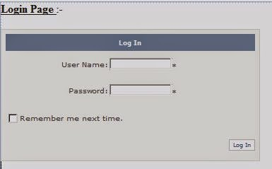](http://4.bp.blogspot.com/-jVH0j6TUM0A/VBVNncZnYoI/AAAAAAAADRg/VKencU19Gf4/s1600/login.JPG)

‘Code in Authenticate Event

If Login1.UserName = "rofel" And Login1.Password = "bca" Then

Response.Redirect("default.aspx")

Else

Login1.FailureText = "Enter Correct User name and Password"

End If

**2. The LoginView Control**

The LoginView control is a web server control used for displaying the two different views of a web page. It helps to alter the page view for different logged in users. The current user’s status information is stored in the control. The control displays appropriate information depending on the user.  
  
The LoginView class provides the LoginView control. The methods, properties and events provided by the login class are as listed below:

**Methods of the LoginView class**

1. DataBind: It helps user to bind the data source through the LoginView control.
2. OnViewChanged: It raises the ViewChanged event after the view for the control is changed.
3. OnViewChanging: It raises the ViewChanging event before the LoginView control changes the view.

**Properties of the LoginView class**

1. Controls: It accesses the ControlCollection object containing the child controls for the LoginView control
2. EnableTheming: It access or specifies the value indicating the themes to be applied to the control
3. RoleGroups: It access the collection of role groups associated with the content templates

**Events of the LoginView class**

1. ViewChanged: It is initiated when the view is changed
2. ViewChanging: It is initiated when the view is in the process to be changed.

The LoginView control at the design time is as shown below:  
  
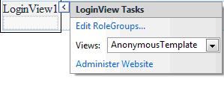

**3. The LoginStatus Control**

It specifies that a particular user has logged into the web site. The login status is displayed as a text. The login text is displayed as a hyperlink but provides the navigation to the login page. The authentication section of the web.config file is useful for accessing the login page URL.   
  
The LoggedIn and LoggedOut are the rwo status provided by the LoginStatus control. TheLoginStatus class provides the control. The methods, properties and events for the control are as mentioned below:  
  
**Methods of the LoginStatus Control**

1. OnLoggedOut: It raises the event when the logout link is clicked by the user.
2. OnLoggingOut: It raises the event when the user clicks the logout link of the control.

**Properties of the LoginStatus Control**

1. LoginImageUrl: It accesses or specifies the URL of the image used for the login link.
2. LoginText: It access the text added for the login link
3. LogoutAction: It retrieves the value for determining the action when the user logs out of the web site.
4. LogoutText: It retrieves the text used for logout the link

**Events of the LoginStatus Control**

1. LogginOut: It is initiated when the user sends the logout request to the server.
2. LoggedOut: It is initiated by the LoginStatus class when the user logout process is completed

The LoginStatus control at the design time is as shown below:  
  
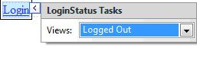

**4. LoginName Control**

It is used for displaying the name of the authenticated users. The Page.User.Identity.Name is used for returning the user name. The control is not displayed if it does not contain any logged in user. The LoginName class is used for the control.   
  
The control does not contain any method, property or events associated with it. The FormatString property is used for displaying the string in the control.   
  
The LoginName control at the design time is as shown below:  
  
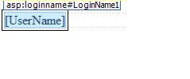

**5. PasswordRecovery Control**

It is used to recover or reset the password for the user. The password is sent through an email as a message at the registration time. The Membership service is used for creating and resetting the password.   
  
The control contains the following three views.

1. Question: It refers the view where the user can enter the answer to the security question.
2. UserName: It refers to the view where the user can enter the username for the password to be recovered.
3. Success: It represents the view where the message is displayed to the user.

The control contains various properties, methods and events as mentioned below:  
  
**Methods of the PasswordRecovery Control**

1. OnSendingMail: It raises the SendingMail event when the user is verified and the password is sent to the user.
2. OnUserLookupErrror: It raises the UserLookupError when the username does not match with the one stored in the database,
3. OnSendMailError: It raises an error when the mail message is not sent to the user.
4. OnVerifyingUser: It raises the event once the username is submitted, and the membership provider verification is pending.

**Properties of the control**

1. Answer: The answer provided by the user to confirm the password recovery through the valid user
2. FailureTextStyle: It accesses the reference to the collection of properties defining the error text look
3. HelpPageIconUrl: It image to be displayed for the link to the password is retrieved

**Events of the control**

1. SendingMail: It is initiated when the server is sending an email message containing the password once the answer is correct
2. AnswerLookupError: It is initiated when the user answer to the question is incorrect
3. VerifyingAnswer: It is initiated when the user has submitted the answer to the password recovery confirmation question

The PasswordRecovery control at the design time is as shown below:  
  
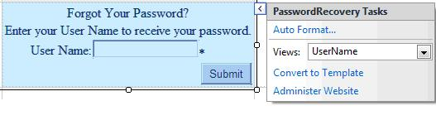

**6. CreateUserWizard Control**

The control uses the Membership service for creation of a new user. The control can be extended to the existing Wizard control. The control can be customized through templates and properties.   
Some of the properties, methods and events related to the control are as mentioned below:

**Properties of the Control**

1. Answer: It retrieves or specifies the answer to the password recovery confirmation question.
2. CompleteStep: It shows the final step of the process for creating the user account.
3. ContinueButtonText: It accesses or specifies the collection of properties defining the look of the control
4. Email: It retrieves the email address of the user
5. LoginCreatedUser: It accesses or specifies the value indicating the new user login once the account is created.

**Events of the control**

1. CreatedUser: It is initiated after the membership service provider has created a new user account
2. CreatingUser: It is initiated before the membership service provider is called for creating user account
3. SendingMail: It is initiated before sending the conformation email on the successful creation of the account
4. SendMailError: It is initiated when the SMTP error occurs during the mail sent to the user.

The CreateUserWizard control at the design time is as shown below:  
  
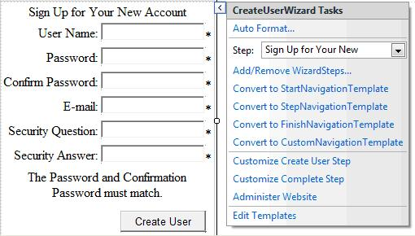

**7. ChangePassword Control**

The control helps user to change the password. The user adds the current password and adds the new password. If the old password is incorrect, the new one cannot be added.   
  
**Properties of the control**

1. CancelDestinationPageUrl: It accesses or retrieves the URL of the page that the user is shown once it clicks the Cancel button.
2. CurrentPassword: It retrieves the current password of a user.
3. DisplayUserName: It retrieves the value indicating whether the ChangePassword control should be display the control and label
4. NewPassword: It retrieves the new password entered by the user
5. UserName: It shows the username for which the password is to be modified.

**Events of the control**

1. ChangedPassword: It is initiated when the password is changed for the user account.
2. ChangePasswordError: It is initiated when there is an error in changing the password for the user account
3. SendMailError: It is initiated when the SMTP error occurs during sending an email message

The ChangePassword control at the design time is as shown below:  
  
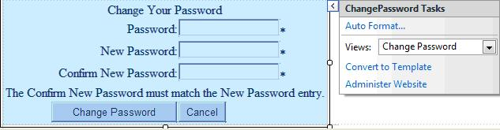  
  
**Implementing Authentication in ASP.NET login controls**  
  
Consider an example to demonstrate the login controls in an ASP.NET application. Perform the following steps to demonstrate the implementation of the login controls in application.

1. Place the login control in the .aspx form and change the AutoFormat style property to Classic.  
     
   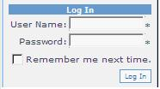
2. Click the Smart Tag and open the Login Tasks and select the Administer Website option.
3. Click the Security link in the window  
     
   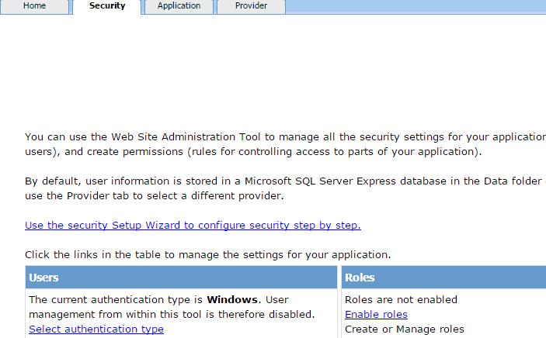
4. Click the Use the security Setup Wizard to configure security step by step link to open the setup wizard
5. Click Next button in the welcome the security setup wizard.  
     
   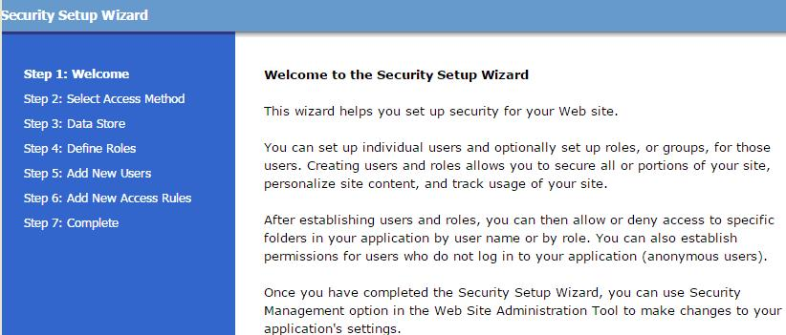
6. Click the From the Internet radio button and click the Next button.  
     
   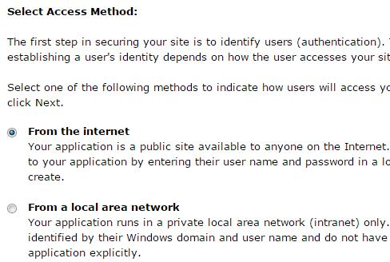
7. Click the Next button in the Advance provider settings page.  
     
   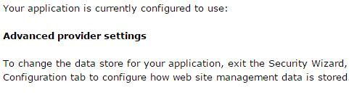
8. Select the Enable roles for this web site check box and click the Next button  
     
   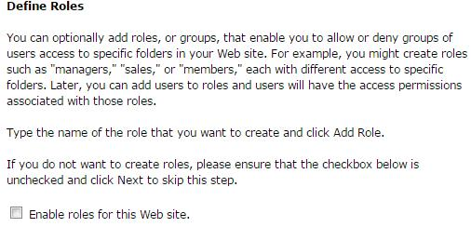
9. Add the details in the text boxes and click the Create User button to create the user account.  
     
   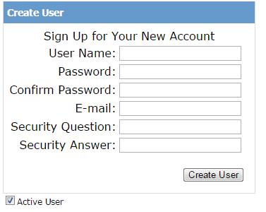
10. Select the All Users radio button in the Rule applies to section.
11. Click the Add this Rule button. Click Next button  
      
    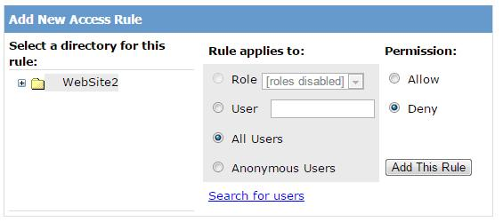
12. Click Finish button, click Close button
13. Add the LoginName and LoginStatus controls on the web page
14. Set the LogoutAction property to Redirect, click the smart tag of the LoginStatus control and select the Logged In option from the Views drop down list.
15. Execute the application and enter the username and password in the text boxes. Click Log In button.
16. The following output is displayed when the application is executed on the server.  
    